 |  |  |  |  |  |  |  |  |  |  |  |  |  |  |  |  |  | MY LIFE MAP A Journal to Help Shape Your Future KATE AND DAVID MARSHALL
An intriguing look at the age-old question of the pursuit of the life.
A must read for anyone facing the ‘What’s next?’ moment in life
 | Reflect on the Past, Evaluate the Present, Map Your Future. |  |  |  |  |  |  |  |  |  |  |  |  |  |  |  |  |  |  |  |  | -Richard Leider, bestselling author of Repacking Your Bags and The Power of Purpose
 | Life isn’t about finding yourself, it’s about creating yourself. My Life Map is a record of your past and a tool to chart the life story you hope to live in the future. Kate and David Marshall, bestselling authors of The Book of Us and What I Love About You, have crafted a guided journal packed with insightful yet accessible writing prompts to aid people at any stage of life in gaining perspective. My Life Map helps people plot a visual road map of their past, present and future in major life areas such as family, friends, work, and play, which can highlight unnoticed patters and act as encouragement to decide what to do with the gift of life.
 |  |  |  |  |  |  |  |  |  |  |  |  |  |  |  |  |  |  |  |  |  |  |  | 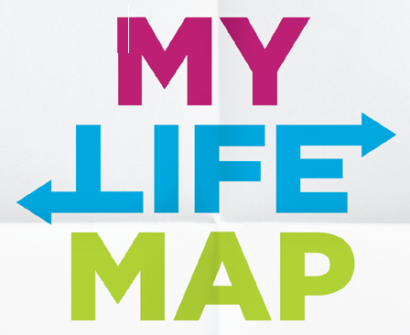A Journal to Help You Shape Your Future
 |  |  | The journal includes chapter on:
- Mapping tips: Why, when, and how to map your life
- Sample journeys: Completed maps of fictitious people at different stages of life
- Past present and future: Exercises for reflecting on your life so far and envisioning your future.
- Life maps: Blank maps to fill in (subject, ten-year, and whole-life maps)
- Putting your maps into practice: Tips and tools for establishing next steps and annual checkup dates
- Bonus material: A tool kid to create and update electronic life maps.
 | My Life Map nourishes self-discovery and personal growth. It helps individuals explore their identity, values, and aspirations. By guiding reflections on life experiences, goals, and relationships, it fosters a deeper understanding of oneself and encourages a more intentional approach to life.
 | 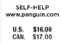 |  |  | 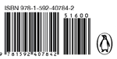 |  |  |  |  |  |  |  | 
KATE AND DAVID MARSHAL
Authors of the best selling The Book of Us and What I Love About You

